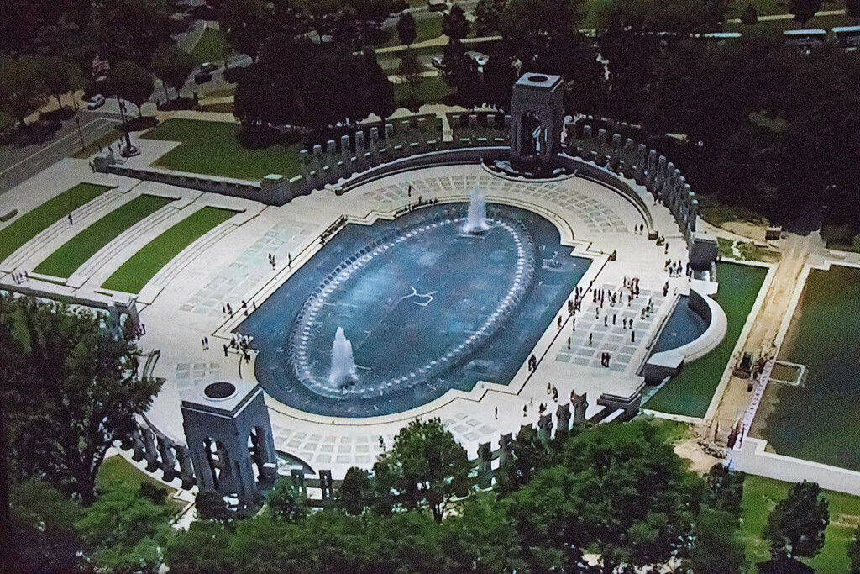

# World War II Memorial

The **World War II Memorial** is a [national memorial in the United States](https://en.wikipedia.org/wiki/List_of_national_memorials_of_the_United_States)[[1]](https://en.wikipedia.org/wiki/World_War_II_Memorial#cite_note-1)[[2]](https://en.wikipedia.org/wiki/World_War_II_Memorial#cite_note-2) dedicated to [Americans who served](https://en.wikipedia.org/wiki/Veteran#United_States) in the [armed forces](https://en.wikipedia.org/wiki/United_States_Armed_Forces) and as civilians during [World War II](https://en.wikipedia.org/wiki/World_War_II). It is located on the [National Mall](https://en.wikipedia.org/wiki/National_Mall) in [Washington, D.C.](https://en.wikipedia.org/wiki/Washington,_D.C.)

The memorial consists of 56 granite pillars, decorated with bronze [laurel wreaths](https://en.wikipedia.org/wiki/Laurel_wreath), representing [U.S. states](https://en.wikipedia.org/wiki/U.S._states) and [territories](https://en.wikipedia.org/wiki/U.S._territories), and a pair of small [triumphal arches](https://en.wikipedia.org/wiki/Triumphal_arch) for the Atlantic and Pacific theaters, surrounding an oval plaza and fountain. On its short axis is a memorial wall of [gold stars](https://en.wikipedia.org/wiki/American_Gold_Star_Mothers#Origin_of_Gold_Star_Symbol) representing the fallen, and opposite, a sloped and stepped entrance plaza leading up to the oval from 17th Street. Its initial design was submitted by Austrian-American architect [Friedrich St. Florian](https://en.wikipedia.org/wiki/Friedrich_St._Florian).

Opened on April 29, 2004, it replaced the [Rainbow Pool](https://en.wikipedia.org/wiki/Rainbow_Pool) at the eastern end of the [Reflecting Pool](https://en.wikipedia.org/wiki/Lincoln_Memorial_Reflecting_Pool), between the [Lincoln Memorial](https://en.wikipedia.org/wiki/Lincoln_Memorial) and the [Washington Monument](https://en.wikipedia.org/wiki/Washington_Monument). Dedicated by [President](https://en.wikipedia.org/wiki/President_of_the_United_States) [George W. Bush](https://en.wikipedia.org/wiki/George_W._Bush) on May 29, 2004,[[3]](https://en.wikipedia.org/wiki/World_War_II_Memorial#cite_note-3) the memorial is administered by the [National Park Service](https://en.wikipedia.org/wiki/National_Park_Service) under its [National Mall and Memorial Parks](https://en.wikipedia.org/wiki/National_Mall_and_Memorial_Parks) group.[[4]](https://en.wikipedia.org/wiki/World_War_II_Memorial#cite_note-4) More than 4.6 million people visited the memorial in 2018

## **History**

View of The World War II Memorial (bottom) and the Lincoln Memorial (top) from the Washington MonumentThe National World War II Memorial plaza

In 1987, World War II veteran Roger Durbin approached Representative [Marcy Kaptur](https://en.wikipedia.org/wiki/Marcy_Kaptur), a [Democrat](https://en.wikipedia.org/wiki/United_States_Democratic_Party) from [Ohio](https://en.wikipedia.org/wiki/Ohio), to ask if a World War II memorial could be constructed. Kaptur introduced the World War II Memorial Act to the [House of Representatives](https://en.wikipedia.org/wiki/United_States_House_of_Representatives) as HR 3742 on December 10. The resolution authorized the [American Battle Monuments Commission](https://en.wikipedia.org/wiki/American_Battle_Monuments_Commission) (ABMC) to establish a World War II memorial in "Washington, D.C., or its environs", but the bill was not voted on before the end of the session. In 1989 and 1991, Rep. Kaptur introduced similar legislation, but these bills suffered the same fate as the first and did not become law.

Kaptur reintroduced legislation in the House a fourth time as HR 682 on January 27, 1993, one day after Senator [Strom Thurmond](https://en.wikipedia.org/wiki/Strom_Thurmond) (a [Republican](https://en.wikipedia.org/wiki/United_States_Republican_Party) from [South Carolina](https://en.wikipedia.org/wiki/South_Carolina)) introduced companion Senate legislation. On March 17, 1993, the Senate approved the act, and the House approved an amended version of the bill on May 4. On May 12, the Senate also approved the amended bill, and the World War II Memorial Act was signed into law by President [Bill Clinton](https://en.wikipedia.org/wiki/Bill_Clinton) on May 25 of that year, becoming [Pub. L.](https://en.wikipedia.org/wiki/Act_of_Congress#Public_law,_private_law,_designation) [103–32](https://uslaw.link/citation/us-law/public/103/32)